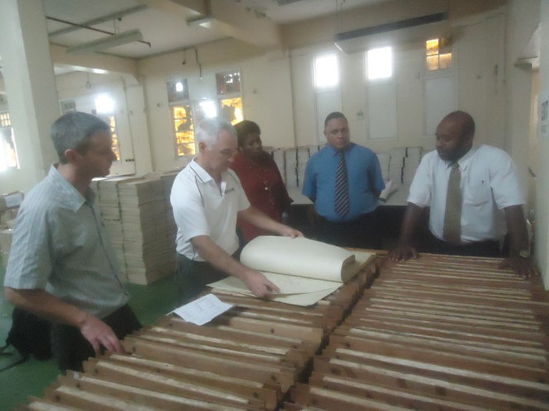
SUVA TRIP
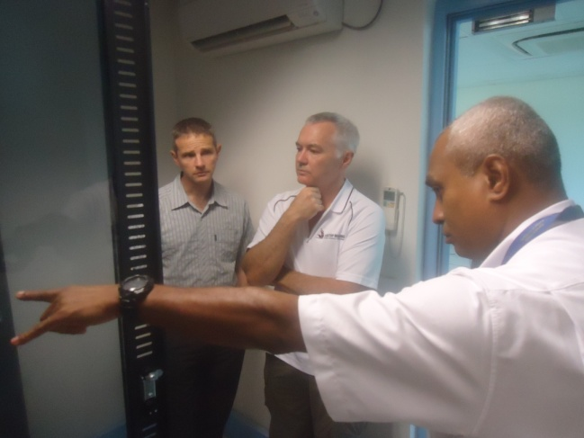

Fiq 1: Len with NIWA Team inside Server Room Fig 2. With National Archives Team

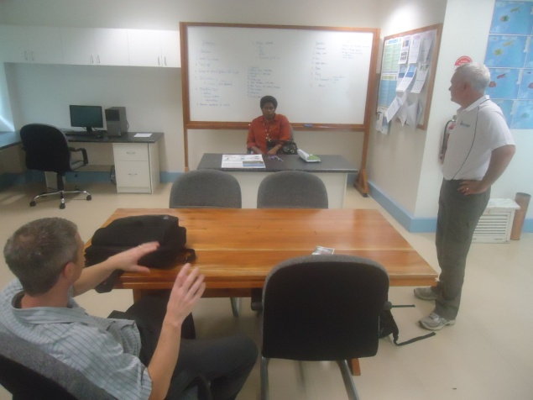
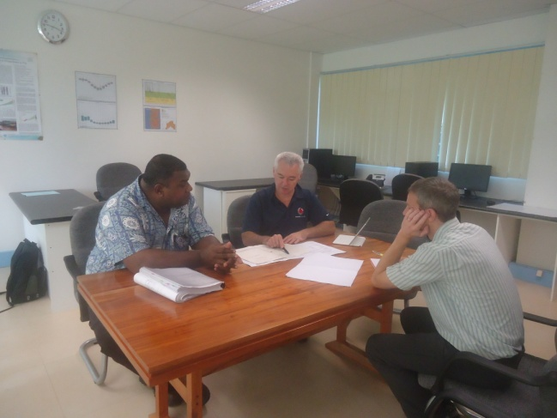
Fig 3. With Mr Mosese Druavesi Fig 4. Friday session discussion @Laucala Bay
Building & Government Architect

